Methodology Note
Supplementary Methodological Information

Contents
Methodology Note
Data Sample
Data Collection
Variable Definitions
Notes on Replication
Case studies: Indonesia & Mozambique
Indonesia
Mozambique
Data Summary

Data Sample
The data sample includes 457 observations of policy advice originating from 293 Annual Reports published between December 1st, 2015, and March 25th, 2021. During this time span, the Fund published a total of 595 total Article IV reports, although the frequency of publication is variable. The following data indicate the relative frequency of policy advice to compensate for the truncated samples in years 2015 and 2021, as well as the drastic decrease in publication frequency during the 2020 pandemic.
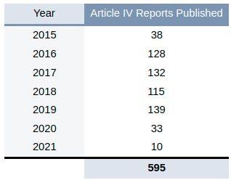

The year observed reflects the year of the Fund’s consultation, indicated in the Article IV Report’s title. Reports published at the beginning of any calendar year often reflect a consultation conducted in the previous year.

Data Collection
The dataset is composed of Article IV reports spanning December 2015 to March 25th, 2021, that include policy recommendations with respect to fossil fuel infrastructure, exports, and privatization of power companies. To ascertain the dataset, the entire population of Article IV reports published in this timeframe (595 total) were reviewed at each instance of the terms listed below. To accommodate differences in the spelling of keywords across UK/US English, singular/plural, tenses, and other possible variations of keywords, all possible permutations of the search terms were observed, either by the inclusion of additional keywords searches, or by use of boolean operators. For example, a search for “subsidy” includes the common variations of the word, including “subsidize”, “subsidise”, “subsidized” “subsidised” or “subsidies”.

Where a keyword was found to exist, the immediate context of the keyword was analyzed for any possible relevance to the policy advice in focus. Each observation therefore does not merely indicate the presence of any particular term or combination of terms – indeed, the terms below are extremely common and would not provide meaningful insights on their own. Rather, each observation indicates the verified presence of the particular policy advice in focus.

Variable | Keyword Search Terms
Dev_Infra_FF | Energy infrastructure, power infrastructure, gas infrastructure, power plant, generator, natural gas, methane, LNG, LPG, refinery, petrochemical, coal, hydrocarbon, ethane, gas production, oil production, pipeline, crude, gas, fuel, oil, energy, power
Privatize_SOE_FF | Privatize, equitization, liquidation, divestment, electric, utility, utilities, privatization, SOE
Reduce_Fuel_Sub | Subsidy, energy subsidy, fuel subsidy, subsidized energy, subsidised energy, subsidized fuel, subsidised fuel

Variable Definitions
Each Article IV report included in the data sample meets one or more of the following criteria:

- The Article IV report advises or supports the development of fossil fuel infrastructure.
Dev_Infra_FF
“no" = 0; "yes" =1

- The Article IV report advises or otherwise supports the privatization of established power or electric SOE utilities.
Privatize_SOE_FF
“no" = 0; "yes" =1

Within this, we then classified the 117 hits further by coding as either direct hits or indirect hits.

- The Article IV report explicitly or implicitly advises the reduction or elimination of energy subsidies.
Reduce_Fuel_Sub:
“no" = 0; "yes" =1

Other Definitions

“Year”
specifies the year of the consultation listed in the Article IV Report’s title, not the year of the Report’s publication date.

“Reference”
specifies the Article IV Report title as listed on the Fund’s website, along with the specific URL where the report can be accessed on the Fund’s website (https://imf.org/). Future access of these documents may require use of the Internet Archive’s “Wayback Machine” (https://web.archive.org/).

Notes on Replication
To execute the keyword search across hundreds of reports, we utilized the Article IV Scanner, an open-access search utility hosted by the IMF Monitor, an online research resource supported by the Economic & Social Research, the Institute for New Economic Thinking, and the University of Cambridge.

To search and assess Article IV reports published after June 1st, 2019 (beyond the immediately available range of reports assessed by the Article IV Scanner at the time of writing) we utilized an open-source local file-indexing software, DocFetcher Pro. While downloading a series of Article IV reports from the IMF website is time-intensive, this method offers a rather expedient search process owed to a more versatile search engine query syntax built off of Apache Lucene.

In the interest of fostering a more rigorous discourse on aggregate analyses of the Fund’s publications, public access would be best served by a central repository of publications for mass-download. Such a repository could encourage more sophisticated analyses, especially with the applications of newer machine learning methods such as natural language processing.

Case studies: Indonesia & Mozambique
The Article IV Reports referenced in the country-level analysis are listed and linked below:

Indonesia
Indonesia: 2020 Article IV Consultation-Press Release; Staff Report; and Statement by the Executive Director for Indonesia
Indonesia: 2019 Article IV Consultation-Press Release; Staff Report; and Statement by the Executive Director for Indonesia
Indonesia: 2017 Article IV Consultation-Press Release; Staff Report; and Statement by the Executive Director for Indonesia
Indonesia: 2016 Article IV Consultation-Press Release; Staff Report; and Statement by the Executive Director for Indonesia
Indonesia: 2015 Article IV Consultation-Press Release; Staff Report; and Statement by the Executive Director for Indonesia

Mozambique
Republic of Mozambique: 2019 Article IV Consultation-Press Release; Staff Report; and Statement by the Executive Director for the Republic of Mozambique
Republic of Mozambique: 2017 Article IV Consultation-Press Release; Staff Report; and Statement by the Executive Director for the Republic of Mozambique
Republic of Mozambique: Staff Report for the 2015 Article IV Consultation, Fifth Review Under the Policy Support Instrument, Request for Modification of Assessment Criteria, and Request for an 18-Month Arrangement Under the Standby Credit Facility-Press Release; Staff Report; and Statement by the Executive Director for Republic of Mozambique
Republic Of Mozambique: 2013 Staff Report For The 2013 Article Iv Consultation, Sixth Review Under The Policy Support Instrument, Request For A Three-Year Policy Support Instrument And Cancellation Of Current Policy Support Instrument

Data Summary
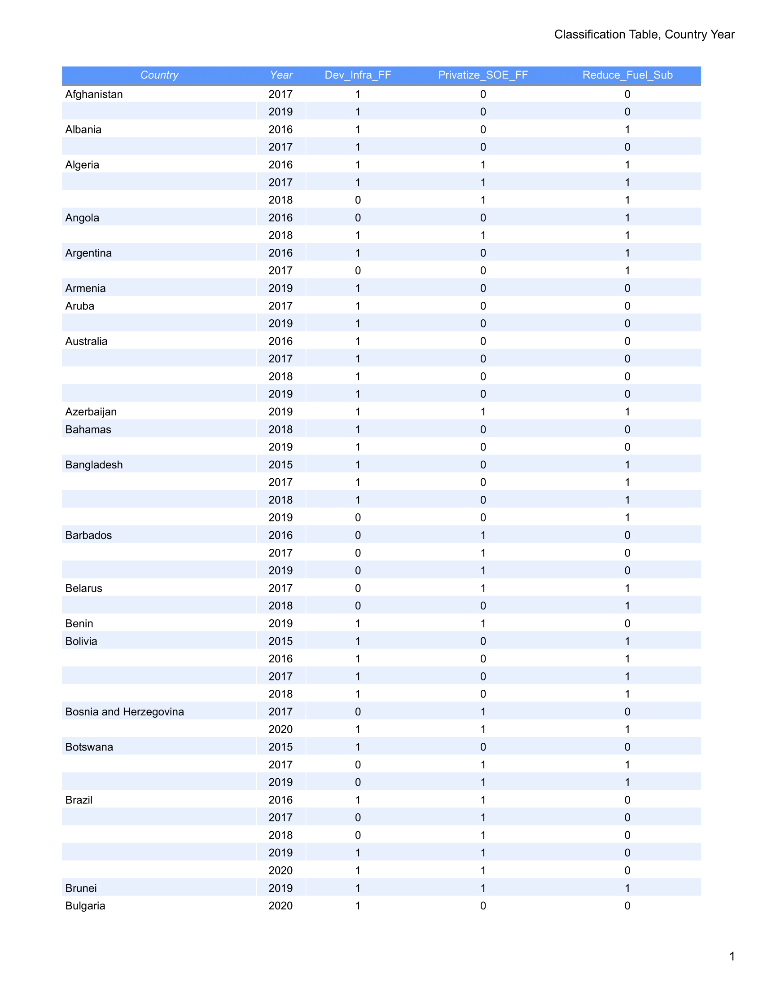
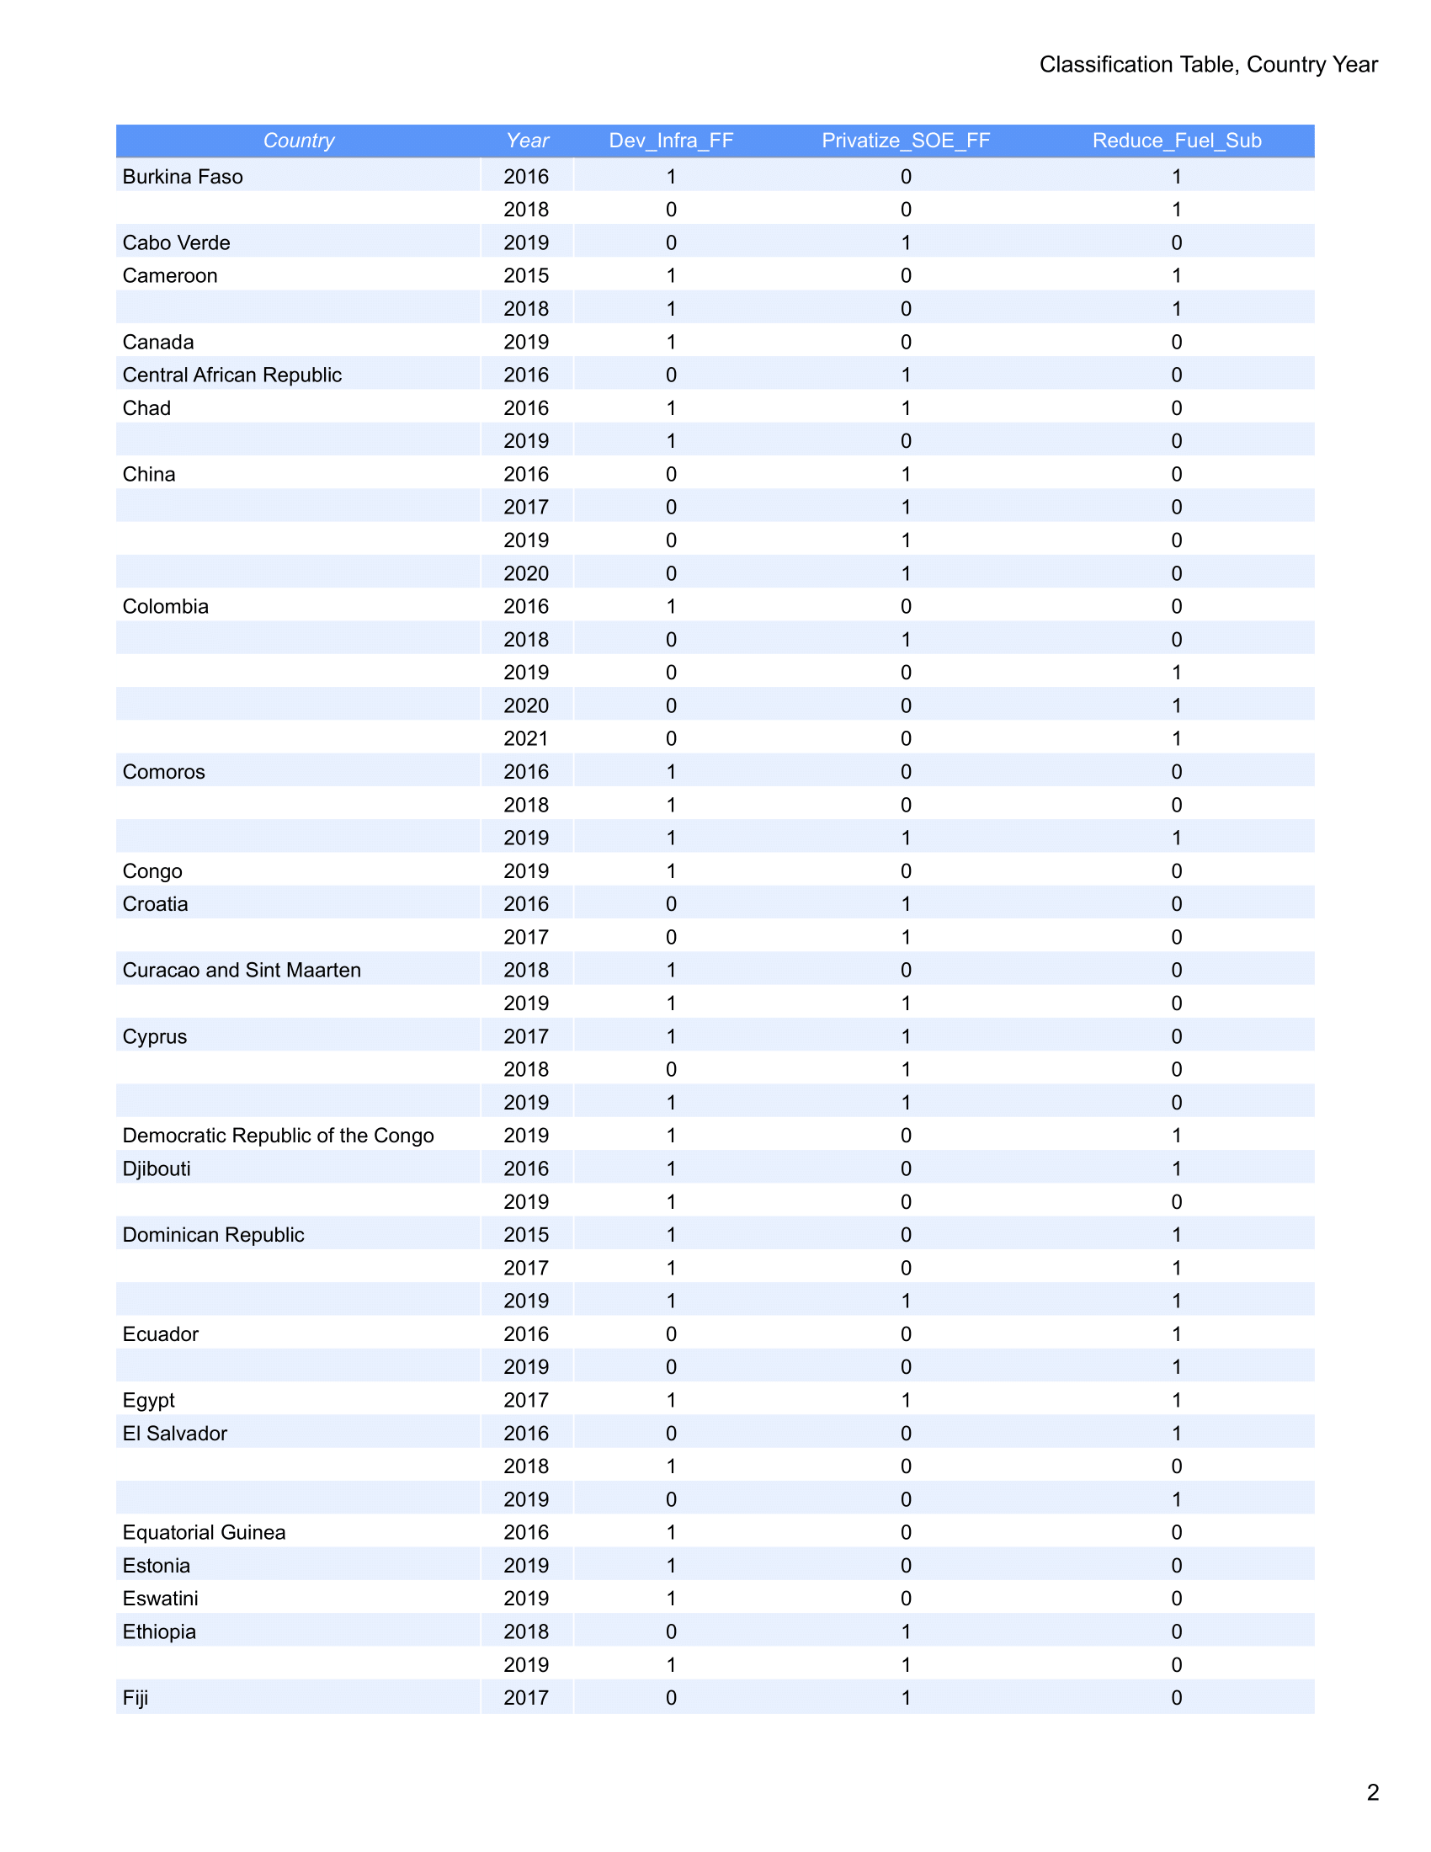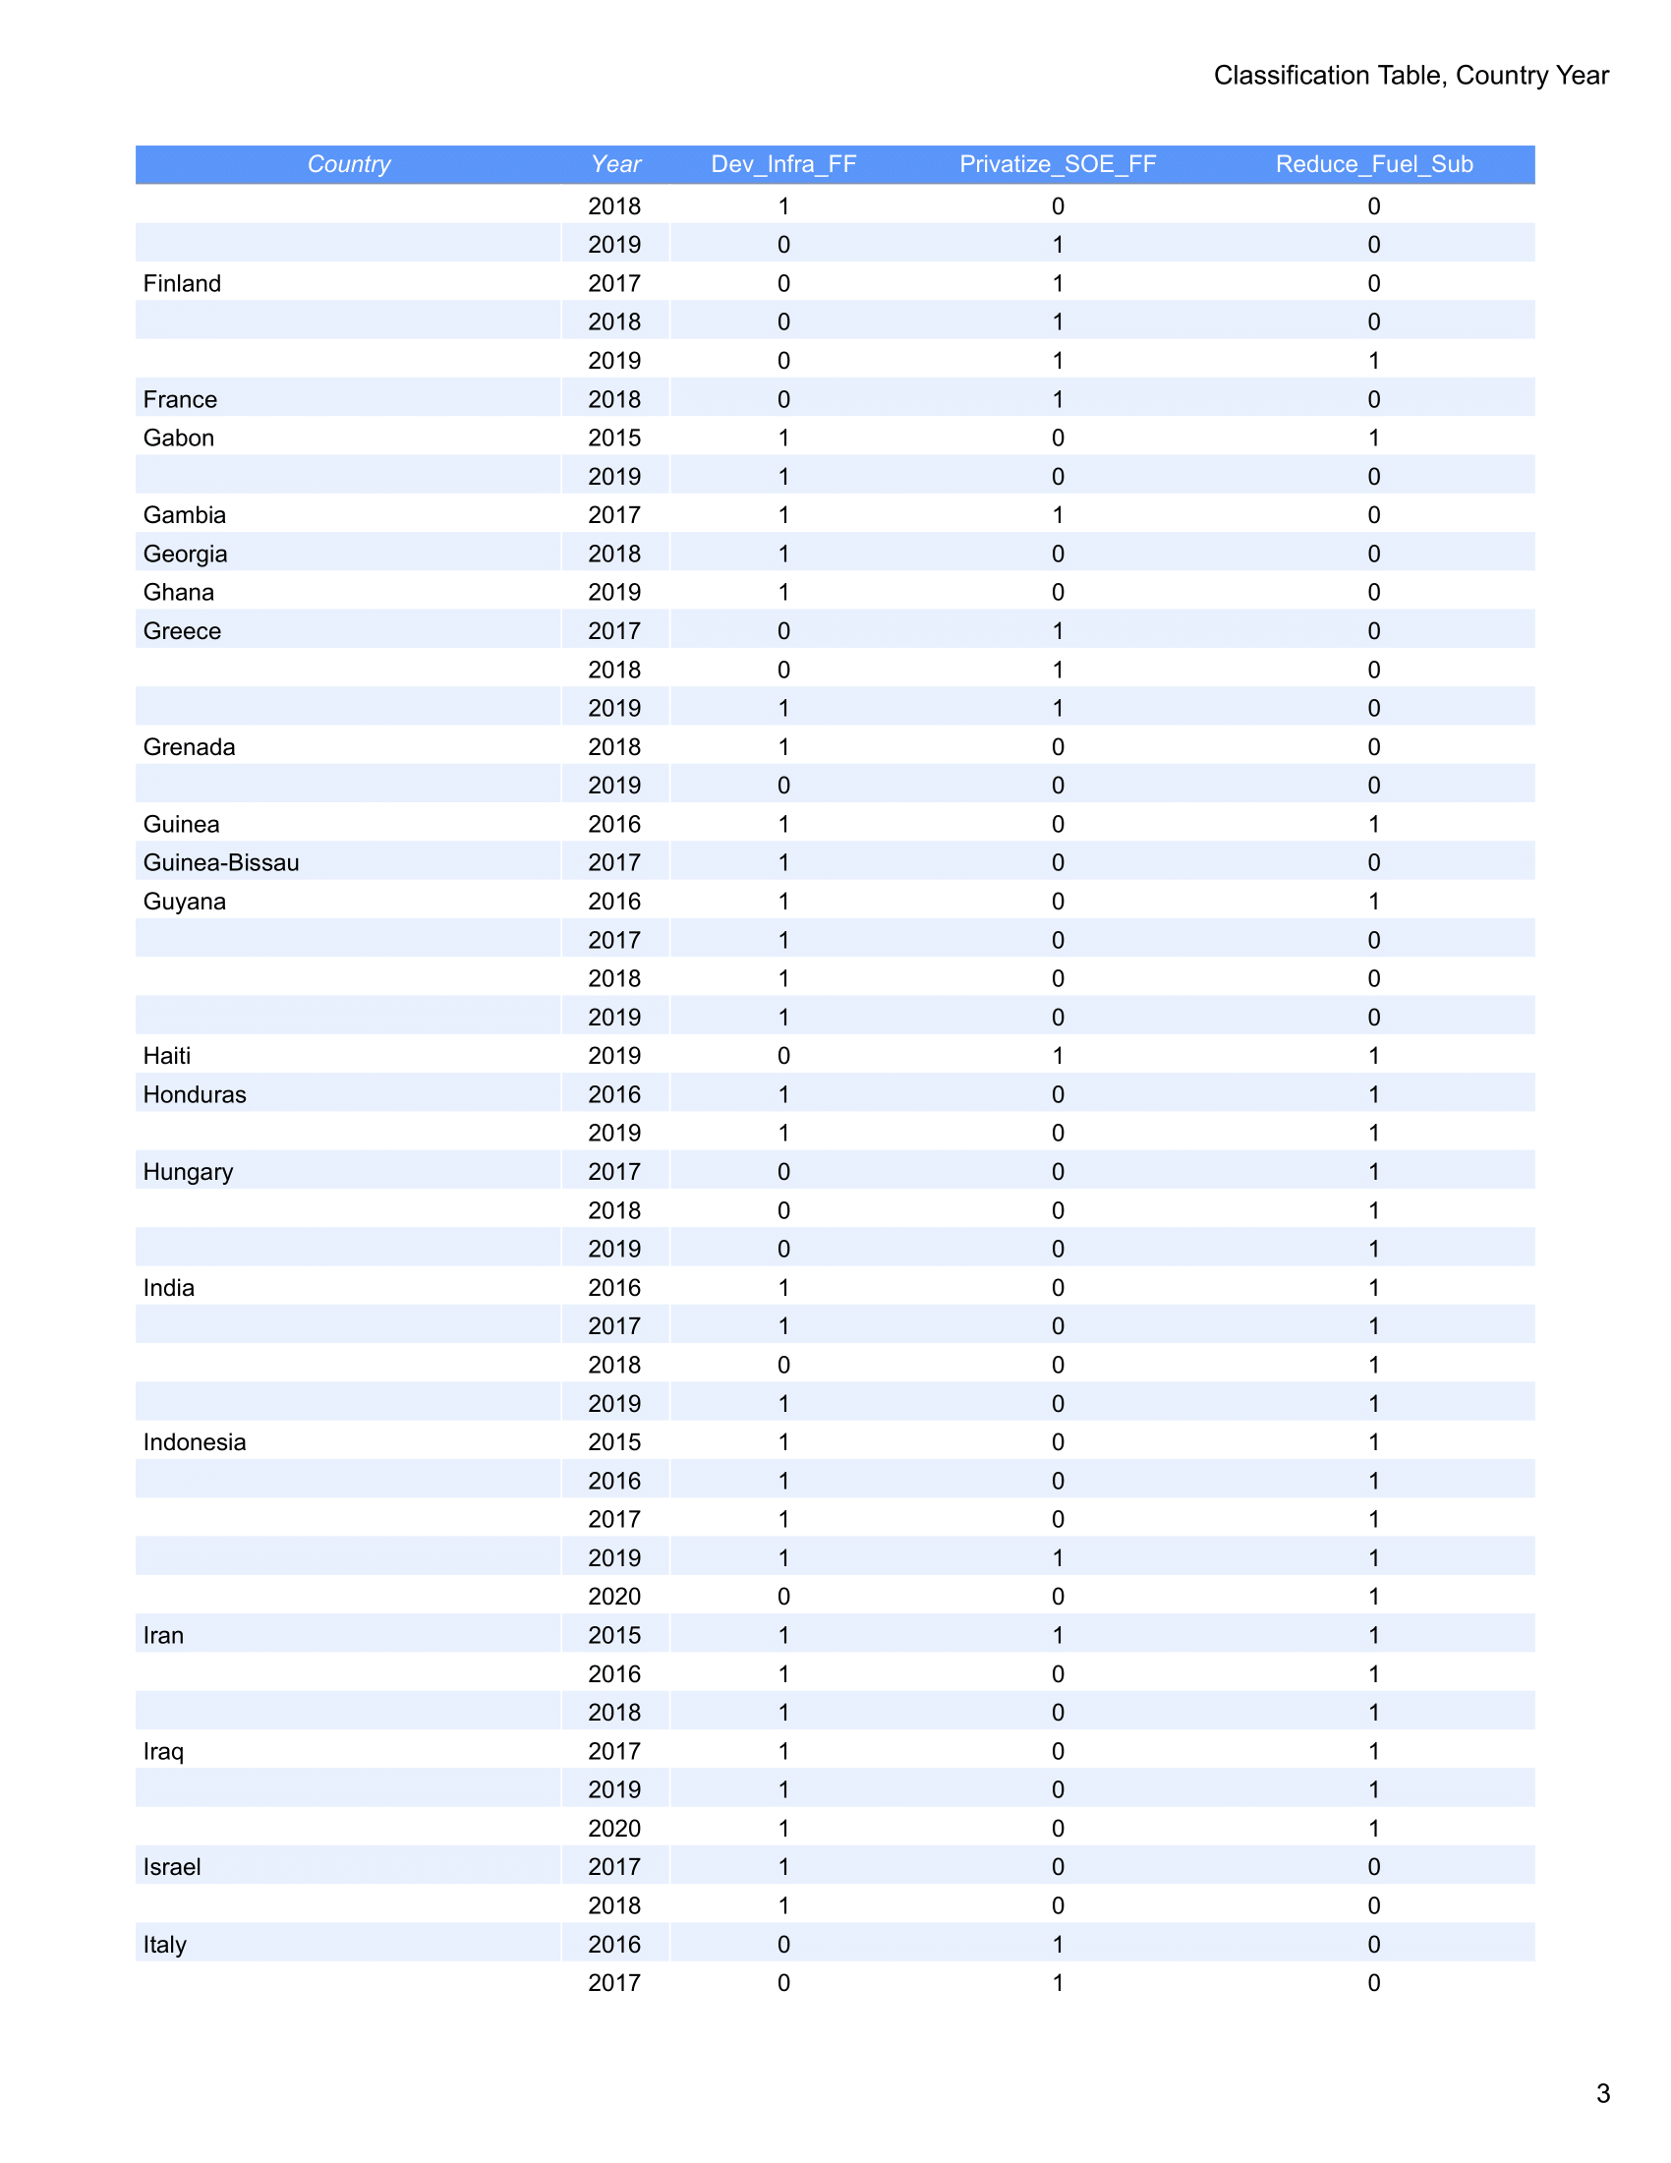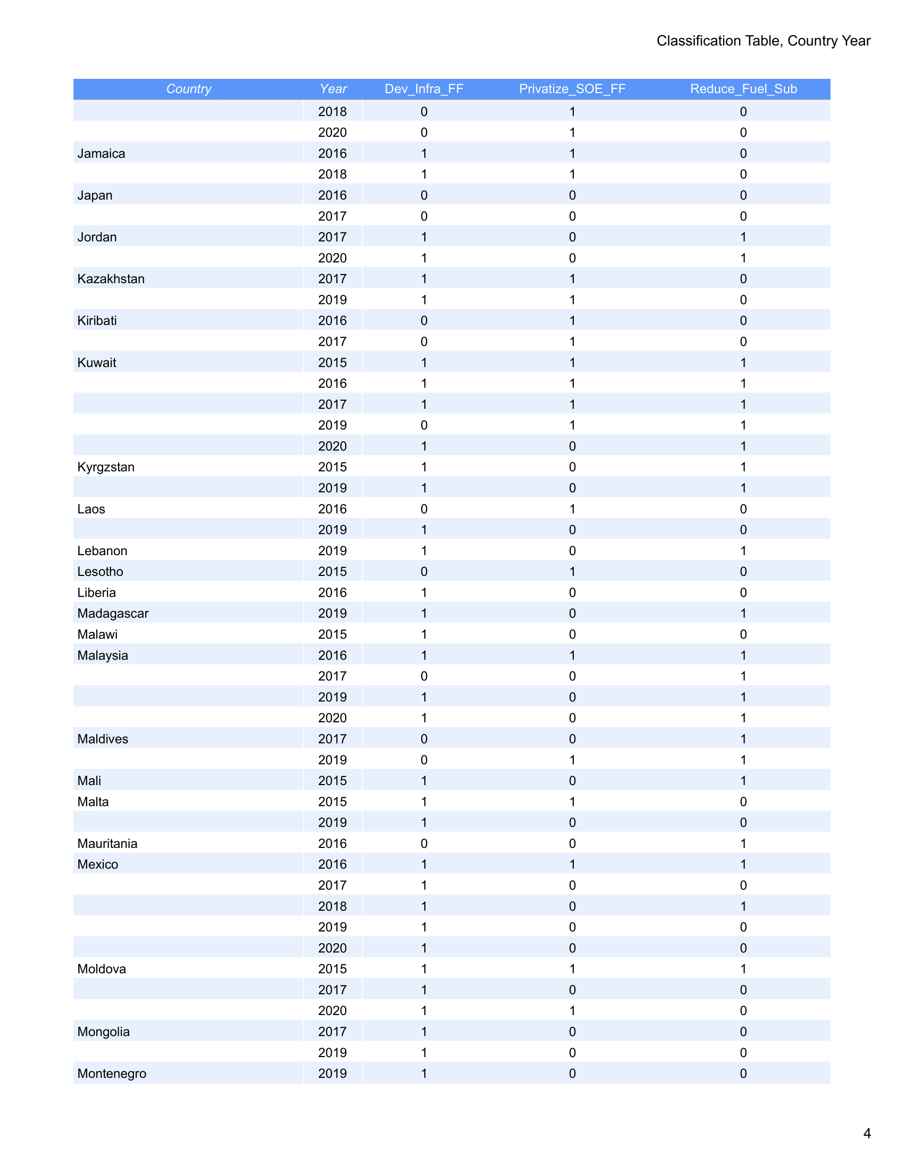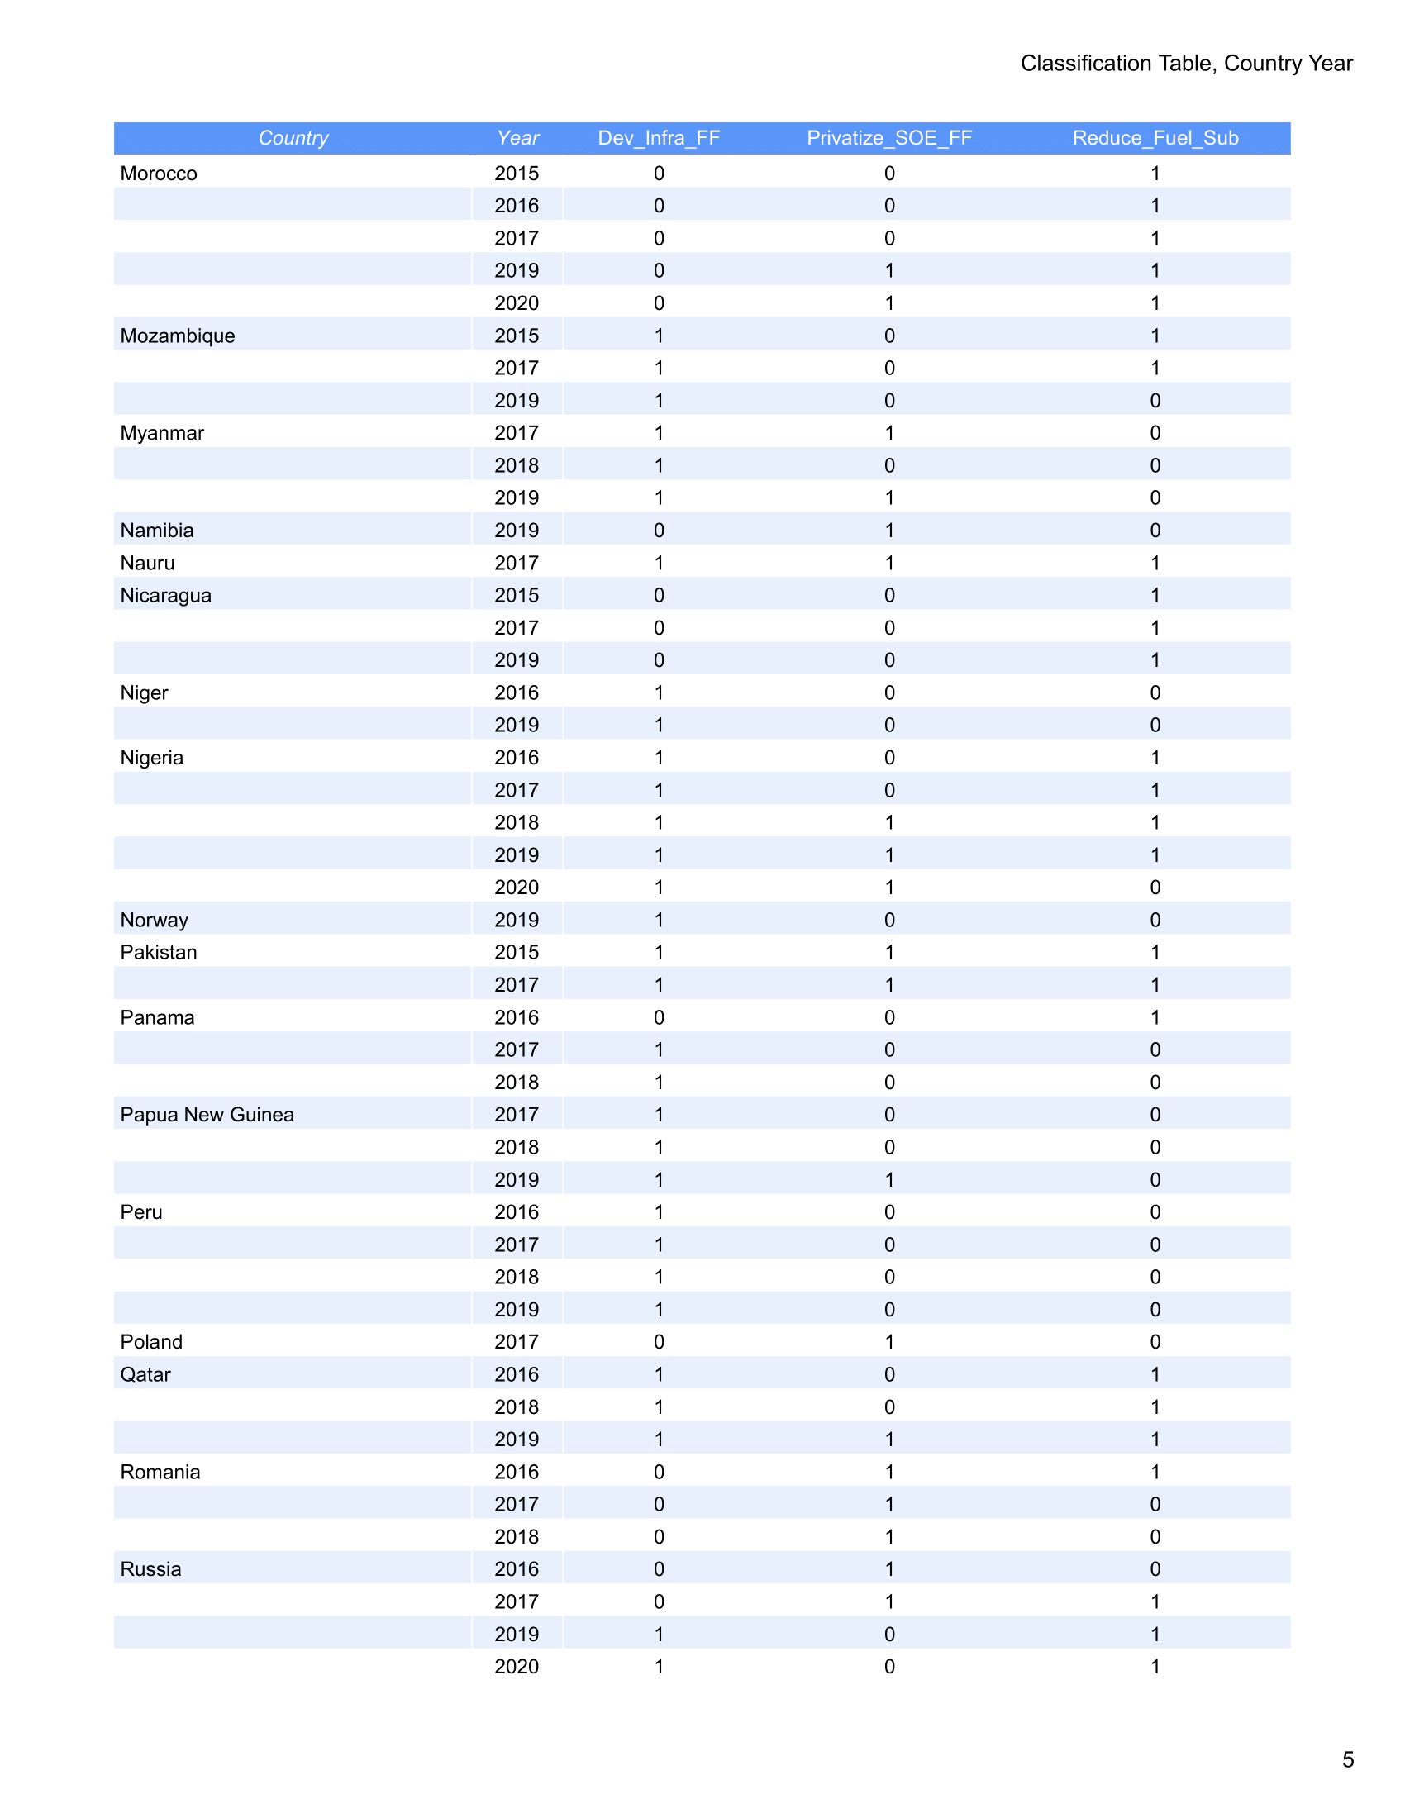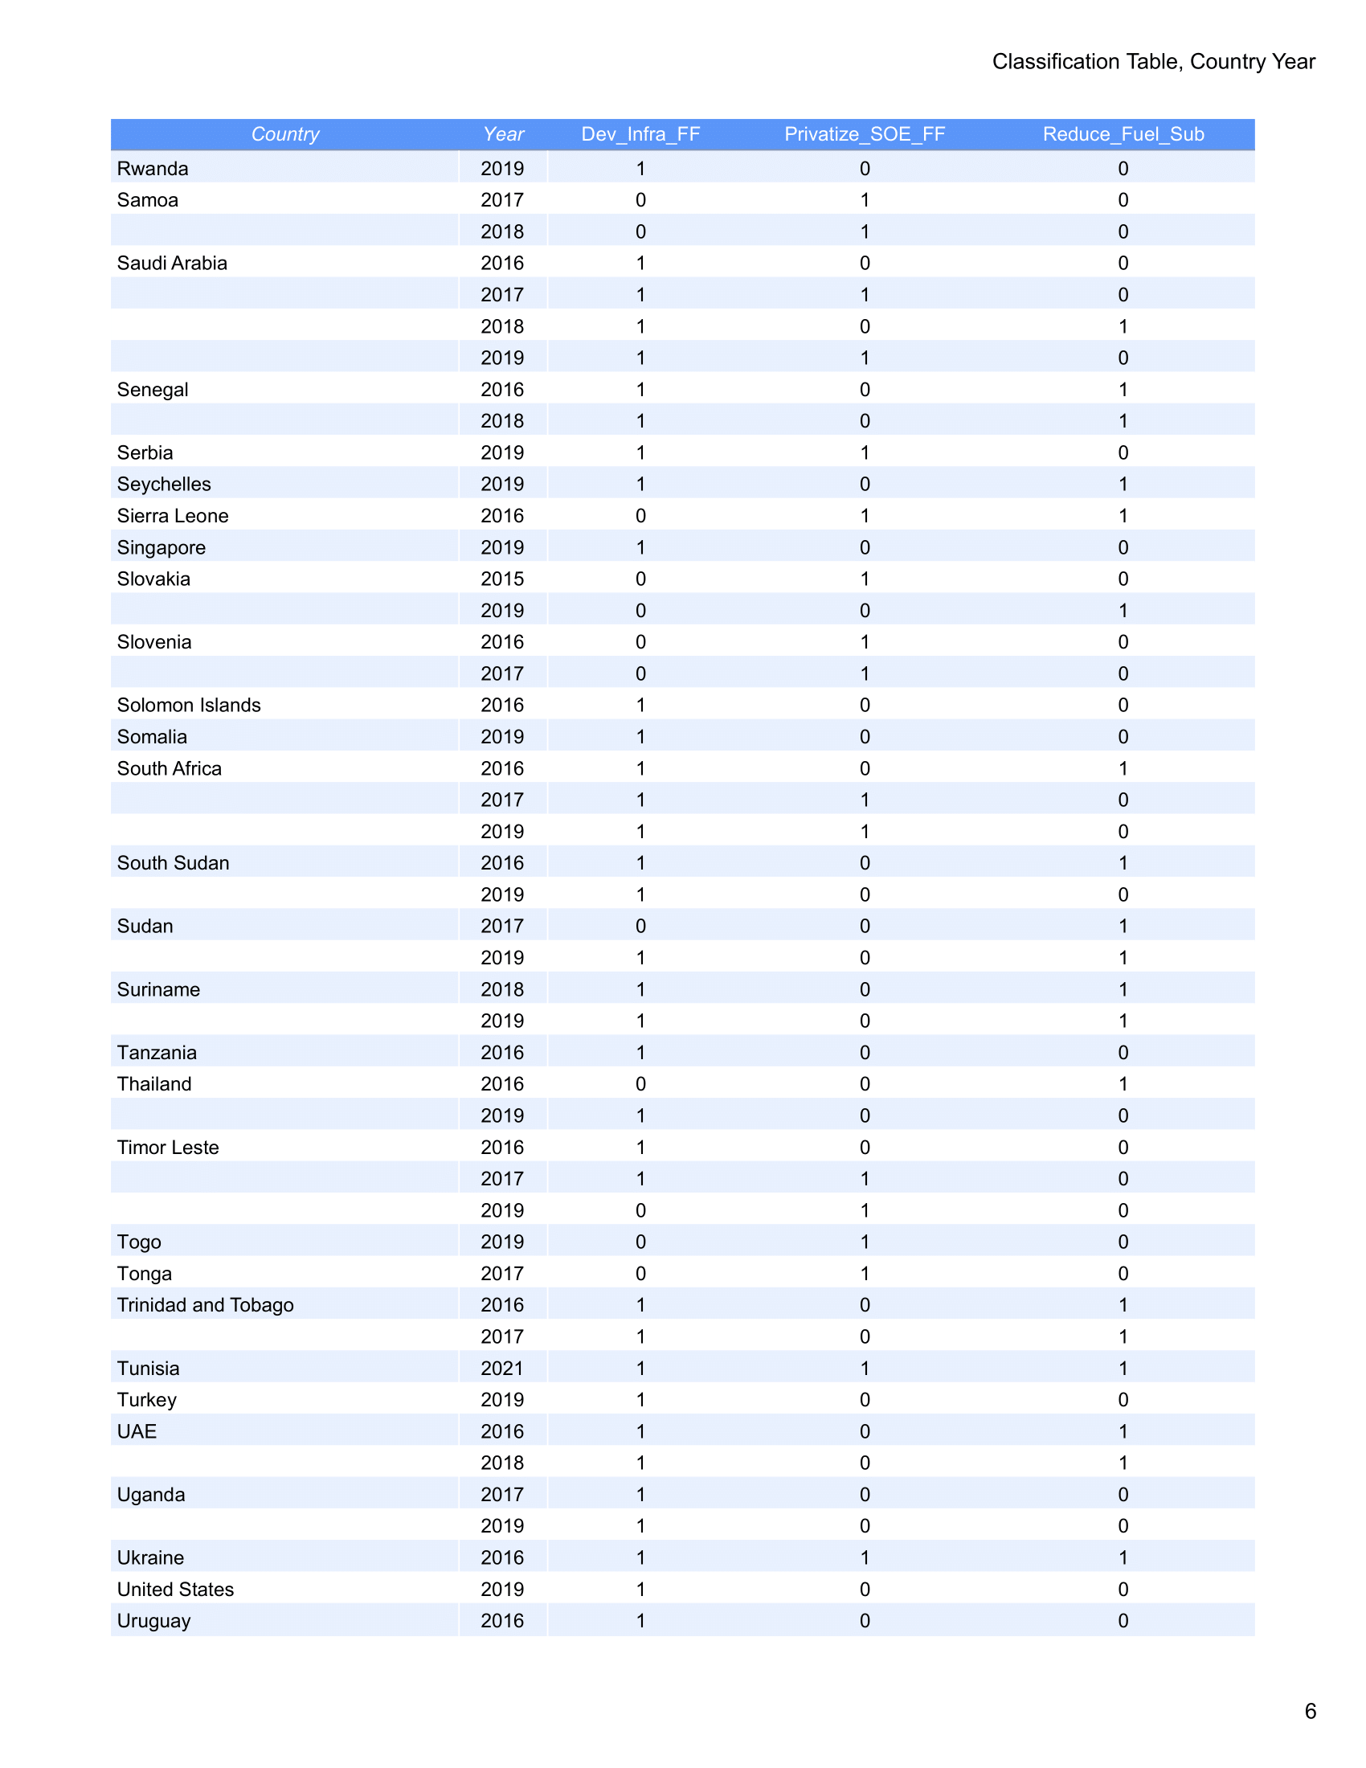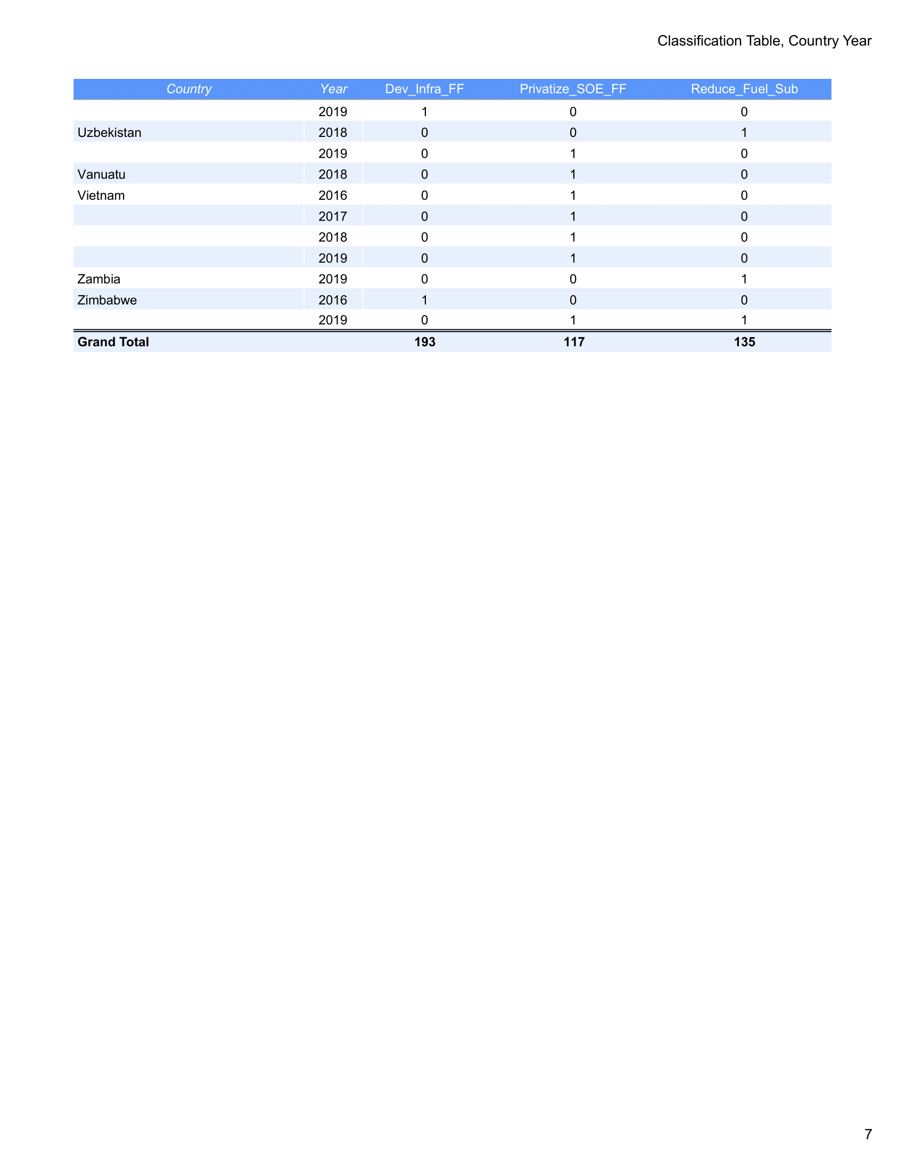

Observations include generalized calls for reduction in energy infrastructure deficits, except where renewable energy projects are cited.
Where specificity is lacking, broad calls for privatization of SOEs are assumed to include power companies and utilities, as there is no discernable difference in the Fund’s treatment of these sectors as essential provisions.
IMF Monitor: Article IV Scanner https://articleivscanner.imfmonitor.org/

